We’re comparing two subsets of time series from the M4 monthly data.

1. Subset with large forecast error increase (relative to the original forecast error): 759 time series that had a 1200% increase in MAE under k-nts+ (k = 3).
2. Subset with small forecast error increase (relative to the original forecast error): 1104 time series that had a 12.4% increase in MAE under k-nts+ (k = 3).

Figure 1 contains plots of the original series from each subset. The series with the large forecast error increase are “smoother” than the noisy time series that had a small forecast error increase. The series on the left have lower spectral entropy values and are easier to forecast.

***Figure 1****: plots of the original time series that had a large increase in forecast error (left) and the time series that had a small increase in forecast error (right).*

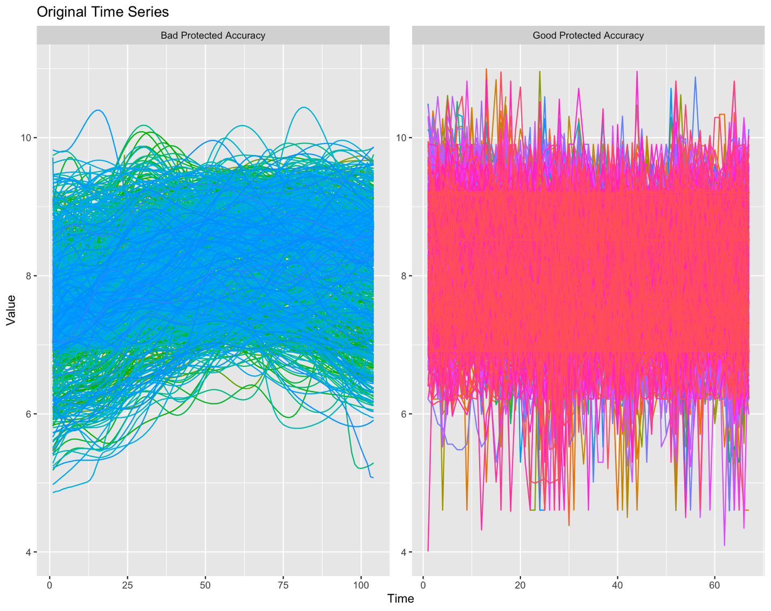

We assess the privacy/utility tradeoff using additive noise with noise parameter . For each time period of each series, a protected value is created by adding random noise proportional to the standard deviation of the original time series:

Where

And is the standard deviation of the th time series.

Figure 2 shows the mean absolute error for SES and DES forecasting models applied to the original time series and to protected series with values of ranging from 0.05 to 3.0. The time series shown on the left in Figure 1 have a low MAE for small values of which quickly increases as increases. The series on the right in Figure 1, had a much more gradual increase in forecast error as increased (these series had a much higher original forecast error to begin with). This supports the notion that protecting series that have poor forecast accuracy to begin with will not seriously degrade forecast accuracy. Note that by the time is large (~ 2 – 3) the protected data sets have somewhat comparable MAE values – the results for the series on the right are better (in terms of percent increase in MAE) because the original error was so large to begin with.

***Figure 2****: mean absolute error across SES and DES forecasting models and all series as a function of the Additive Noise parameter s. Note that corresponds to the original data.*A graph of different colored lines

The average spectral entropy of the protected data sets exhibits a similar pattern to the MAE values. The series on the left start with a relatively low average spectral entropy (indicating good forecastability) but exhibit a rapid increase in the average spectral entropy as increases. The series on the right have very high average spectral entropy to begin with. In other words, we don’t make the forecast results much worse by swapping values between the series on the right.

***Figure 3****: average spectral entropy across all series as a function of additive noise parameter s. Note that corresponds to the original data.*

***Figure 4****: Feature distributions from the original and k-nTS+ versions of the series with the large forecast error increase.*

Figure 4 plots some of the feature distributions from the original and k-nTS+ versions of the time series that had a large increase in forecast error. The features selected for swapping were *variance*, *spike, mean, max level shift, x_acf1 (first autocorrelation coefficient), max var shift, and hurst.* Some of the feature distributions are well maintained, such as the mean and the variance. These features measure overall location and spread of the time series values. Features that depend on temporal relationships *between* points are poorly maintained. For example, the feature e_acf1, which is the autocorrelation of the error component of the decomposed time series, shows extremely strong autocorrelation in the original series that is destroyed in the protected series.

***Figure 5****: Feature distributions from the original and k-nTS+ versions of the series with the small forecast error increase.*

Figure 5 plots some of the feature distributions from the original and k-nTS+ versions of the time series that had a small increase in forecast error. Most of the feature distributions are very well maintained. Overall, the features that depend on the temporal relationships between between time series points are much weaker in these time series. For example, the error component of the decomposed time series exhibits very little autocorrelation.

Our method appears capable of consistently maintaining features that depend on the overall distribution of the time series points (e.g., mean, variance, skewness, kurtosis). What is lacking is a way to maintain features that depend on the temporal relationship between time series points. In each period we swap in a value from a nearest neighbor, but there is no guarantee that this point will maintain any trend, seasonality, autocorrelation, etc. with the previously swapped points. We are introducing too much randomness into series that have really good forecast accuracy and strong predictive features to begin with.